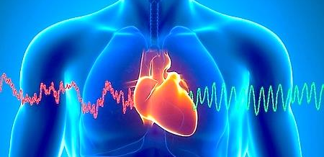
Heart Sound
Recorder Graph

Understanding the Heart Sound Recorder

The Heart Sound Recorder is a computer-based low risk general wellness monitor which uses the principles of auscultation to observe heart sounds. During this non-invasive procedure a specialized microphone is placed over each of the four valve areas of the heart while graphing the sound and movement. The heart’s reaction to certain stressors, (i.e. chemical, nutritional, and emotional), can be observed using this type of device. Certain types of heart stress can be monitored by observing the RATE, RHYTHM, and TONE of the heart cycle on the graph.

♥ Your nervous system controls the RATE at which your heart beats. One side of your nervous system (sympathetic) manages your “fight or flight” response and can accelerate your heart rate. The other side (parasympathetic) manages your “rest and digest” response and can slow your heart rate. You need a healthy balance between the two.
♥ The RHTHYM of your heart should show a specific work to rest ratio on the graph. Your heart should be resting twice as long as it is working. Observations are made to see if your heart is working too hard, or not working hard enough.
♥ The TONE of your heart is referring to the strength of the ventricles as they push blood through your body. The height and the width of the ‘lub dub’ sound your heart makes on the graph, shows how efficiently your heart is pushing blood through your body and refilling to prepare for the next cardiac cycle.

The Heart Sound Recorder can be an important tool in evaluating your overall health and then in following the progress you are making when under proper wellness care. Making changes to your stress level, diet, lifestyle, and nutritional status will provide you with greater endurance, ability to rest, and overall wellbeing.

Preparing for the Heart Sound Recorder Graph

- Be well hydrated

- Be dressed so that you can comfortably get down to one thinner layer of clothing. A sports bra works well for women.

- Do not eat or drink caffeine 2 hours prior to the test as sounds of digestion can mask a solid reading of the heart.

- Give yourself a relaxed time frame around your scheduled appointment.
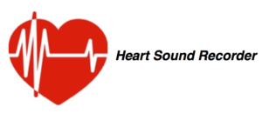

As with any wellness device, recommendations for lifestyle changes implied by using this technology should be undertaken only with the guidance of a licensed physician, therapist, or holistic healthcare practitioner. The findings from this device can be used to support, but should not be used in place of medical therapies and recommendations of your medical professional.

